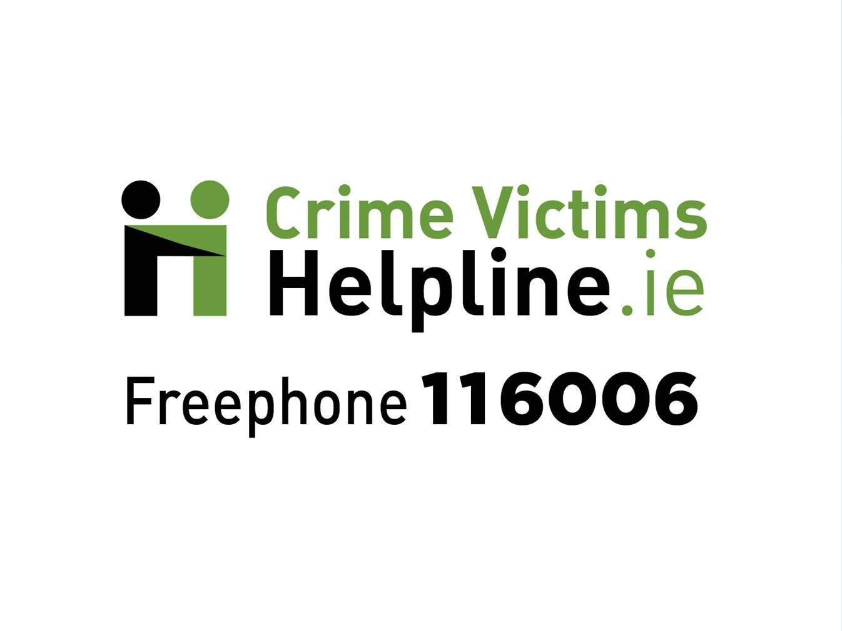

mariem@crimevictimshelpline.ie
www.crimevictimshelpline.ie

Volunteer Application

YOUR CONTACT DETAILS
First name | Surname
Are you over 18? | How did you hear about volunteering with CVH? (a friend, website, etc.)
Yes ¨ No ¨
Home Address |  | Email Address
 |  | Telephone

VOLUNTEERING AVAILABILITY
Please indicate (X) the times you may be available to volunteer between the hours of 10:00 am to 7:30 pm. This is not a commitment or an expectation. We will use the information to gain a general sense of your availability.
 | Monday | Tuesday | Wednesday | Thursday | Friday
Morning
Midday
Late Afternoon
Evening

INFORMATION
Why are you interested in being a volunteer with the Crime Victims Helpline?
Please tell us about any educational background, work or volunteering experiences that would be relevant to the volunteer role at the Crime Victims Helpline.
Is there anything else that you would like us to know in considering your volunteer application?
REFEREES
Please provide names and contact information of two referees:
Referee 1
Name
How known to you
Telephone number
Email

Referee 2
Name
How known to you
Telephone number
Email

We have your permission to contact your references for the purpose of ascertaining your suitability for a volunteer position at the Crime Victims Helpline. ☐ Yes

DATA PROTECTION
I give my consent to Crime Victims Helpline (CVH) to record, maintain and process my personal data for the purposes of my volunteer placement. I understand that my data will not be shared with any other parties outside CVH.

Applicants Signature | Date

Please return your application to mariem@crimevictimshelpline.ie or in the post to Crime Victims Helpline, 6-7 Hanover Street East, Dublin 2, D02 W320.

